Huntingdon County Friends of the Library – 2024 Membership Form

The Friends of the Huntingdon County Library membership levels:
☐ Bookworm $10 ☐ Bundle of Bookworms – Family Membership $15
☐ Book Lover $20 ☐ Book Collector $25 ☐ Other ______

Name: _________________________________________________________________
Address: _______________________________________________________________
City, State, Zip Code: ____________________________________________________
Phone (____)________________ Email: _____________________________

Please make checks payable to “Friends of the Huntingdon County Library” and mail address forms and contributions to: Friends of the Huntingdon County Library; 330 Penn Street; Huntingdon, PA 16652.

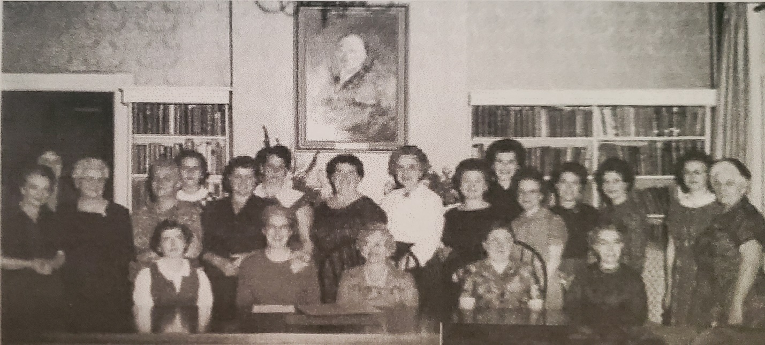

Thank you for your support!

